Caravaggio

On entering The National Gallery’s Beyond Caravaggio exhibition you are immediately ensconced within a dark and hushed environment, much like the mood and colour palettes used by the various artists on show.
The black walls with the lack or minimal directional paths to follow and the low eye level/ head height of the paintings allows you to focus on the displayed work, room by room. It also removes you from other distractions such as architectural detailing and so on and so forth. This encourages you to forget where you are and alleviates any unnecessary straining or craning’ of the neck to look at these works of art.
The small darkened rooms act as a maze in that they seemingly aim to be make the visitors imagine that they were walking through the narrow winding streets or alleys of a time gone by in almost any city. One could feel themselves walking through the ancient streets of Rome or Barcelona. This is then further accentuated by the afore mentioned eye line of the paintings, allowing you to feel as though you were a voyeur looking through private windows at the scenes depicted as moments captured in time. In fact it is due to this, combined with the lack of other visual distractions (curators notes printed on black plaques) that I was not even aware that there were more floors to the exhibition and only realised upon leaving that I had only seen three out of an apparent eleven rooms. The downfall for me however was how this contributed strongly to how quickly the rooms became cramped, preventing you from stopping to properly examine and admire the works of art as you would soon be jostled out of the way by other oncoming groups, for I believe we were all given a set period of time in which to do so, too little time. That would be my only negative point regarding the exhibition. (322 WORDS)
Most of the works I did get to see were listed as oil on canvas with the odd few gouaches (mixed media) ones too. (346 WORDS)
Almost all of the paintings had vague and dark internal backdrops matching the walls of the exhibition, making the external spacial design of the exhibitions rooms an extension of the art works themselves, allowing us to focus on the characters portrayed within in their realistic depictions. (392 WORDS)
Surprisingly the size of the canvases ranged from medium to the extra large, which did not seem to preliminarily coincide with David Hockneys secret knowledge documentary (more on that later) - which threw me off for sure. (428 WORDS)
The themes depicted throughout the exhibition (but heavily on Caravaggio’s) – all seemed to focus on moral and ethical dilemmas, religious connotations, and mythology. An example of this would be; (456 WORDS)

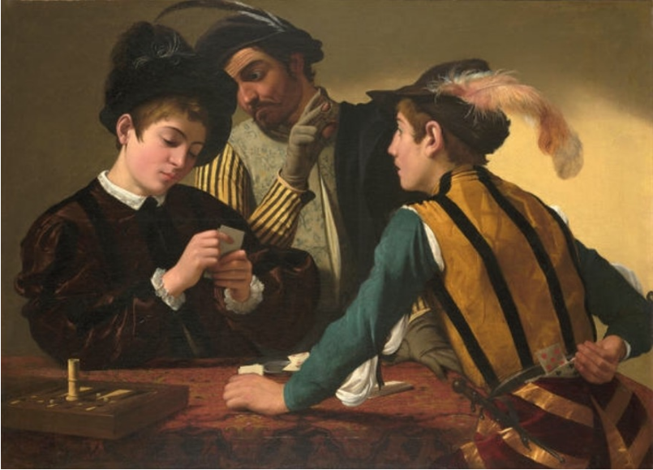
Cardsharps

- Michelangelo Merisi Da Caravaggio (1571 – 1610)
- Italian
- 1594 (16th century)
- Oil paint on canvas
- The National Gallery (London)

A young boy is being duped and looses his innocence (in essence) when a third non player looks ‘over his shoulder’ to see the boys hand while signalling it out to the second player. Caravaggio is a theatrical painting director showing moral vibes much like Shakespeare did with his writing and directing of plays. (528 WORDS)
As well as;

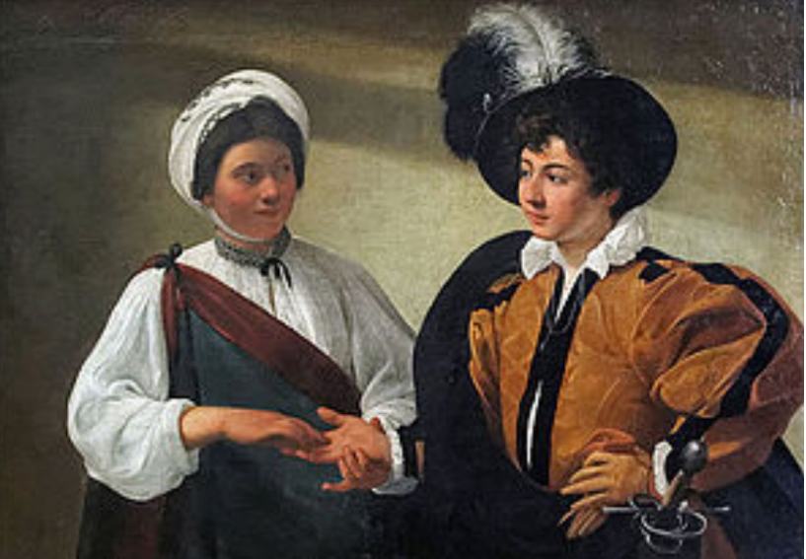
The Fortune Teller

- Michelangelo Merisi Da Caravaggio (1517 – 1610)
- Italian
- 1599 (16th century)
- Oil paint on canvas
- Musee Du Louvre (Paris)
- Another original also appears to be in Pinacoteca Capitolina (Rome)

A naïve, foppish and rich young man is being taken advantage of by the gypsy telling his fortune. She does so by using her feminine wiles to distract him while she slips the ring off of his finger, again another directorial painted form of story telling warning us of moral implications to various human desires.
Both of the above Caravaggio’s depict how it is innocence and naiveté who loose or get taken advantage of as well as mocked. (639 WORDS)
In direct comparison to The Fortune Teller above, we have;

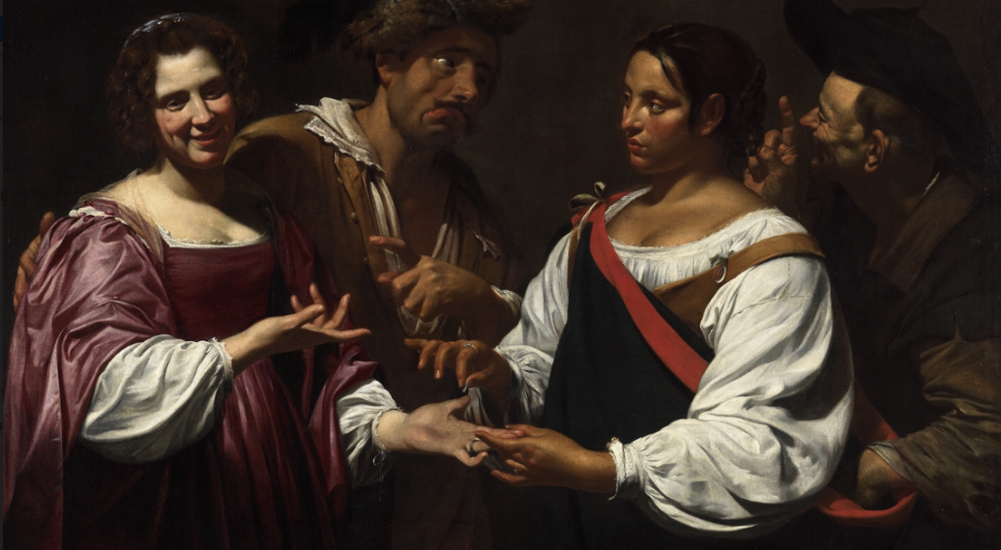
The Fortune Teller

- Simon Vouet (1590 – 1649)
- French
- 1620 (17th century)
- Oil paint on canvas
- The National Gallery of Canada (Ottawa)
- Photograph to scale displayed (The National Gallery – London)

Created as a response to Caravaggio’s work of the same name, but more theatrically exaggerated. In Vouets version we have not only (700 WORDS) more characters but a twist to the plot. Instead of doing the robbery and fulfilling her stereotyped expectations, the gypsy herself is being robbed. By bringing more characters into the plot we get a rounded out imagery with the woman on the right again distracting the gypsy lady, who I’m not completely sure is staring at the first man also on the left who seems to be signalling something regarding the first woman. There is then the second man who’s on the right and appears to be tutting at the first man. With the two outer characters being so jovial they create the added drama and light heartedness in contrast to Caravaggio’s painting.
We then have; (816 WORDS)

Christ Appearing To Saint Peter On The Appian Way
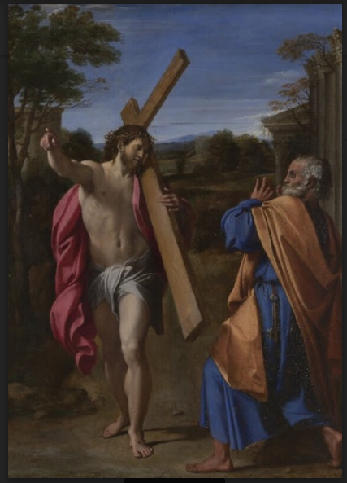

- Annibale Carracci (1560 – 1609)
- Italian
- 1601 – 1602 (17th century)
- Oil paint on wood
- The National Gallery (London)
In relation to religious undertones we now have a direct version above depicting a vision Saint Paul had of fleeing from crucifixion and comes across Jesus Christ merrily almost walking back to Rome to be crucified a second time, resulting in him returning to Rome and then being crucified. (891 WORDS)

Regarding David Hockneys Secret Knowledge documentary we know that the use of optics was discovered originally through the ability to draw realistic, natural, photographic, true to life, small scale (as opposed to sight size where you draw or paint images slightly larger as judged by the naked eye) – detailed imagery. (941 WORDS)
We also know that the camera Lucida was used in 1812 where there would be a small projection or illusion created that only the artist would be able to see, this would have only allowed for making marks to miniature scale.
Through looking back at historical art work it became clear that something significant had to have occurred approximately around 1420 due to everybody suddenly being able to draw realistically with clear individualised characters. Another clue regarding optical presence is the strong lighting and contrast with focus that came about. In both of The Fortune Teller paintings we can see that the lighting comes in from the left hand side, whilst Caravaggio’s is more natural and bright Vouet has used his in a focussed spotlight effect which is not as natural but marries with the theme of exaggerated drama. However Carracci has used softer lighting depicting dusk or dawn, still using it to correctly highlight his image but more gently also coming from the left.
We also learn that the details and realism could not be achieved via the previously well known net or grid method where artists would focus on each square at a time to slow build up the entire image proper,(1144 Words) as previously painted pictures would paint textiles as flat stiff things that did not follow the lines of the body or drape naturally, neither would metal or armour have the right points of lighting or depth.
This is showcased through Jan Van Hyck’s works and his extreme attention to life like realistic detail.

While the lighting may be correct in the above paintings regarding the big picture, and the fabrics are draped correctly in their natural form. You can see that Caravaggio has forgotten to detail the light, shine and depth on the sword hilt of the boy on the far right in Cardsharps, unlike his The Fortune Teller. The same could be said regarding the depth and textures of the fabrics in comparison between the two as well as between Carracci’s ‘flat’ textiles in Christ Appearing To Saint Peter On The Appian Way and the depth and attention to texture in Vouets The Fortune Teller. (1300 WORDS)

We also learn that in 1540 the use of curved or concave mirrors would have been heavily used and guarded secretively by artists. The guild of Saint Luke’s and the Guild of mirrors are also known to have been of the same guild and building. This would create coloured movie projections, limitations of this were that the further back you placed the mirror the better the focus and detail of the projection. Another example of modern technology in direct correlation to this method is Photoshop or other photo editing software, for example Lorenzo lotto’s image of a nude in danger of being crashed into by a wave. She would have been painted in private quarters before having the background edited in around her, and as Hockney points out, you can still see the suggestion of a table top that she would have modelled on. I initially believed that this was what Carracci used to paint Christ Appearing To Saint Peter On The Appian Way however Brunelski’s perspective scale of objects to the naked eye would have had to be used and was not ‘created’ yet. (1485 WORDS)

A direct example of pre lens concave mirrors versus the clear lens is Caravaggio’s two Bacchus portraits. The image done using mirrors is not as focused and has a slightly shakier hand, next to the later painting the image is sharper, clearer, and more focused due to the lens method enabling photographic looking paintings as they were easier to manipulate and move around. However it meant that all of the images would be reversed from right to left. It also created some discrepancies for others regarding proportions not matching due to tilting the canvas or lens creating optical illusions. (1584 words) Another problem created of painting through optics is that the centre of your canvas would be the hot spot or focus as it were of the lens, so in order to create a multi faceted image you would have to roll or move a large canvas in different directions to fill out the different sections as you would only get clear focus on the centre point. For these reasons I believe all of the artists used lens over mirror, not forgetting the lines of sight being slightly of focus to where they would have been looking if they were all on set together, much like modern CGI films would be harder to pull off for actors if they did not have a ping pong ball to focus their directional gaze.
Do I think that photography killed art? No I don’t to be honest, we have simply expanded on our tools and progressed the technological aspects much like these artists did for their generation. However, I can see how as a society we have begun to loose some of our traditional skills and appreciation for it, but as society ventures further down this technological route, we have to remind ourselves to preserve as much of our heritage as we can for future generations to ponder on as we do now. (1803 WORDS TOTAL)

